**SALES PERFORMACE OPTIMIZATION IN RETAIL**

Project submitted to the

SRM University – AP, Andhra Pradesh

for the partial fulfilment of the requirements to award the degree of

**Bachelor of Technology/Master of Technology**

In

**Computer Science and Engineering**

**School of Engineering and Sciences**

Submitted by

**Sree Charan Korrapati (AP21110010457)**

**Udith Kumar Maddi (AP21110010479)**

**Janardhan Rega (AP21110010518)**



Under the Guidance of

**Prof.** **Sriramulu Bojjagani**

**SRM University–AP**

**Neerukonda, Mangalagiri, Guntur**

**Andhra Pradesh – 522 240**

**[November 2024]**

**Certificate**

**Date: 3-Nov-24**

This is to certify that the work present in this Project entitled **“Sales performance optimization in RETAIL”** has been carried out by Sree Charan, Udith Kumar, Janardhan Rega under my supervision. The work is genuine, original, and suitable for submission to the SRM University – AP for the award of Bachelor of Technology/Master of Technology in **School of Engineering and Sciences.**

**Supervisor**

(Signature)

Prof. Sriramulu Bojjagani

Designation,

Affiliation.

**Co-supervisor**

(Signature)

Prof. / Dr. [Name]

Designation,

Affiliation.

**Acknowledgements**

We would like to express our sincere gratitude to everyone who has contributed to the successful completion of our project, Sales Performance Optimization in the Retail Industry. First and foremost, we extend our deepest appreciation to our mentors and professors, whose expert guidance and continuous support have been invaluable. Their insights into data analysis, Hive, R programming, Python, and Power BI provided us with the foundation and knowledge to tackle the challenges of this project effectively.

We are also grateful to our academic institution for offering the resources and environment that enabled us to explore and develop our skills in big data and analytics. Additionally, we thank our peers and team members for their collaborative efforts, dedication, and shared vision, which made this project an enriching and rewarding experience. Their enthusiasm and commitment were instrumental in helping us achieve our objectives and bring this project to fruition.

Lastly, we would like to acknowledge the support of our families and friends, whose encouragement and patience kept us motivated throughout this journey. This project has been a significant learning experience, and we are grateful to everyone who played a role in its success.

**Table of Contents**

Certificate 2

Acknowledgements 3

Table of Contents 4

Abstract 5

Statement of Contributions 6

List of Tables 7

List of Figures 10

Introduction 11

Methodology 12

Discussion 14

Concluding Remarks 38

Future Work 40

**Abstract**

This project explores sales optimization strategies for Amazon's e-commerce platform, aiming to identify factors that impact product performance across different regions, product categories, and seller metrics. Leveraging data visualization and statistical analysis, the project examines key performance indicators (KPIs) such as seller ratings, average delivery times, weather effects, and product popularity in various countries. Utilizing R programming for detailed data exploration, visualizations in the form of bar charts, line graphs, and pie charts highlight trends that inform sales strategies and potential areas for improvement. Additionally, Power BI dashboards present an overview of top-performing brands and low-performing products by country, providing actionable insights for enhancing Amazon’s sales and customer satisfaction. The findings offer Amazon’s stakeholders a clear understanding of optimization levers that can drive increased sales and market competitiveness.

**Statements of Contribution**

Sree Charan Korrapati (AP21110010457)

* Partial Preprocessing of Datasets
* Partial Hive programming
* Dashboard (Overview)

Udith Kumar Maddi (AP21110010479)

* Dashboard (Analysis 1)
* Partial Preprocessing of Datasets
* Partial Hive Programming

Janardhan Rega (AP21110010518)

* R Programming (R studio)
* Dashboard (Analysis 2, Focus)
* Documentation

**List of Tables**

**Amazon Power BI Table:**

Date Added: The date when the seller or product information was added to the database.

category: The category of products the seller offers.

sellerlink: A link to the seller's profile or store on the platform.

sellerlink-url: The URL of the seller’s page on Amazon.

sellerstorefront-url: The URL to the seller’s storefront on Amazon.

sellerproductcount: The total count of products offered by the seller.

sellerratings: The overall ratings received by the seller.

sellerdetails: Additional details about the seller.

seller business name: The name of the seller's business.

businessaddress: The physical address of the seller's business.

Count of seller brands: The number of unique brands the seller is associated with.

Max % of negative seller ratings - last 30 days: Maximum percentage of negative ratings the seller received in the past 30 days.

Max % of negative seller ratings - last 90 days: Maximum percentage of negative ratings the seller received in the past 90 days.

Max % of negative seller ratings - last 12 months: Maximum percentage of negative ratings the seller received in the past 12 months.

Hero Product 1 #ratings: The number of ratings for the seller's first highlighted product.

Hero Product 2 #ratings: The number of ratings for the seller's second highlighted product.

Sample brand name: The name of a sample brand associated with the seller.

Sample Brand URL: The URL of the sample brand’s page.

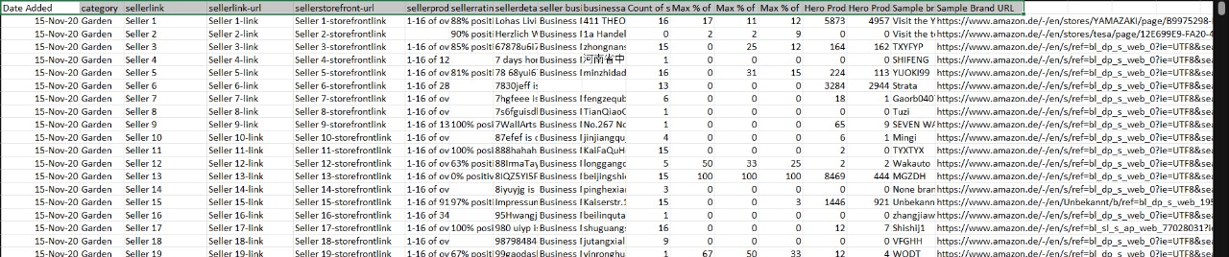

**Delivery_Data Table:**

Agent_Age: The age of the delivery agent.

Agent_Rating: The rating given to the delivery agent based on performance.

Drop_Latitude: The latitude coordinates of the delivery drop-off location.

Drop_Longitude: The longitude coordinates of the delivery drop-off location.

Order_Date: The date on which the order was placed.

Order_Time: The time when the order was placed.

Pickup_Time: The time when the order was picked up by the agent.

Weather: The weather conditions at the time of delivery.

Traffic: The traffic conditions during the delivery period.

Vehicle: The type of vehicle used for the delivery.

Area: The area or locality of the delivery location.

Delivery_Time: The total time taken to complete the delivery.

Category: The category of the product being delivered.

Country: The country where the delivery took place.

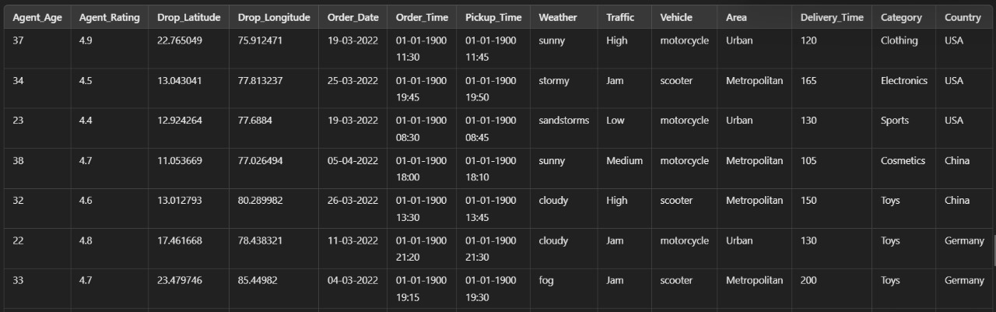

**List of Figures**

1. Dataset Preprocessing Images:

Refer pages 14-16

1. Hive Programming outputs:

Refer pages 20-27

1. Power BI dashboard:

Refer pages 31-33

1. R Programming (Graphs & charts)

Refer pages 35-36

**Introduction**

In this project, Sales Performance Optimization in the Retail Industry, we aim to conduct an in-depth analysis of delivery and sales data to identify key performance factors, uncover inefficiencies, and pinpoint potential areas for improvement. By exploring a range of metrics—such as delivery agent performance, delivery times, customer satisfaction ratings, traffic patterns, weather conditions, and product categories—we intend to gain a comprehensive understanding of factors impacting sales and delivery efficiency.

Utilizing powerful data tools including Hive, R, Python, and Power BI, we will process and visualize this information to derive actionable insights that can directly address issues within the sales and delivery framework. Our goal is not only to streamline processes but also to establish a data-driven foundation for strategic decision-making, leading to enhanced customer satisfaction, reduced delays, and improved operational efficiency.

Through this analysis, we aim to implement effective, data-backed solutions that optimize the entire retail experience, from order placement to final delivery. By addressing identified gaps in the delivery and sales process, we intend to support better resource allocation, drive customer loyalty, and strengthen the brand's competitive advantage. Ultimately, this project aims to foster a more resilient, responsive, and efficient retail system capable of adapting to fluctuating demands and varied market conditions, ensuring long-term growth and sustainability for the business.

**Methodology**

To achieve the goals of our project, Sales Performance Optimization in the Retail Industry, we adopted a multi-step approach, including data preprocessing, Hive-based analysis, Power BI dashboarding, and visualization with R programming. Each stage leveraged specific tools and techniques to analyze different dimensions of sales and delivery performance.

**Data Preprocessing:** We started by cleaning and preparing the data from the amazon_powerbi and delivery_data tables to ensure consistency and readiness for analysis. During preprocessing, we handled missing values, standardized data types, and transformed relevant columns. For example, we calculated delivery durations using Order_Time, Pickup_Time, and Delivery_Time, which provided insights into operational efficiency. Geographic information like Drop_Latitude and Drop_Longitude was prepared for regional analysis, and categorical data was encoded where necessary.

**Hive-Based Data Analysis:** Once preprocessed, the data was loaded into Hive to conduct in-depth analysis using SQL queries. Hive’s distributed processing capabilities allowed us to work efficiently with large datasets, extracting valuable insights from columns like sellerratings, sellerproductcount, Count of seller brands, and time-based metrics like Order_Date and Order_Time. We analyzed seller performance metrics over different periods (e.g., negative ratings over 30, 90, and 12 months) and calculated aggregate statistics to understand trends in customer satisfaction, product popularity, and regional demand.

**Power BI Dashboard Creation:** Based on the insights derived from Hive, we built an interactive dashboard in Power BI to visualize key metrics. The dashboard provided a centralized view of seller performance, delivery efficiency, and demand patterns. Through visualizations like bar charts, heatmaps, and trend lines, we showcased metrics such as top-performing sellers, popular products, delivery time variations, and regional demand distributions. The Power BI dashboard allowed stakeholders to easily explore data and identify trends and areas for improvement.

**R Programming for Advanced Visualization:** To further enhance our analysis, we used R programming to create detailed visualizations and perform statistical analyses. In R, we visualized relationships between variables, such as how weather and traffic conditions (from Weather and Traffic columns) impacted delivery times. We also created time-series visualizations to analyze peak order times and seasonal trends in sales performance. R’s advanced plotting capabilities enabled us to gain deeper insights into the data and complement the Power BI dashboard with more customized visualizations.

By following this methodology, we were able to systematically preprocess and analyse the data, build an insightful dashboard, and perform advanced visualizations, providing a comprehensive view of sales performance and delivery efficiency in the retail industry. This structured approach allowed us to identify key areas for optimization and deliver actionable insights to enhance retail operations and customer satisfaction.

**Discussion**

**Preprocessing:**

. **Library Import:**

Imported essential libraries: numpy and pandas for data manipulation and analysis.

**Data Loading:**

Loaded the dataset (amazon dataset.csv) into a panda DataFrame to work with structured data.

**Initial Data Inspection:**

Used head() and tail() to view the first and last rows of the data.

Used describe() to get summary statistics of numerical columns for an overview of the data distribution.

Checked for missing values with isnull() and isnull().sum().

Handling Missing Values:

Replaced all missing values in the dataset with '0' using fillna('0', inplace=True).

Imputed missing values in the Agent_Age column with the mean of that column.

Converted the Agent_Rating column to a numeric type, replacing non-numeric values with NaN, and then filled any remaining missing values with the mean of the column.

**Data Type Conversion:**

Converted Order_Date column to datetime format, handling errors by setting invalid dates to NaT.

Converted Order_Time and Pickup_Time columns to datetime format, specifying the time format and handling errors similarly.

**Text Normalization:**

Standardized the Weather column by converting all values to lowercase and stripping extra whitespace.

**Dropping Irrelevant Columns:**

Removed unnecessary columns like Order_ID, Store_Latitude, and Store_Longitude to focus on relevant information for analysis.

**Saving Preprocessed Data:**

Saved the cleaned and processed data to a new CSV file (PP_amazon_data.csv).

Reloaded the new file to verify the preprocessing results and check the data structure with info () and describe ().

These preprocessing steps provide a clean, structured dataset that is ready for further analysis and visualization

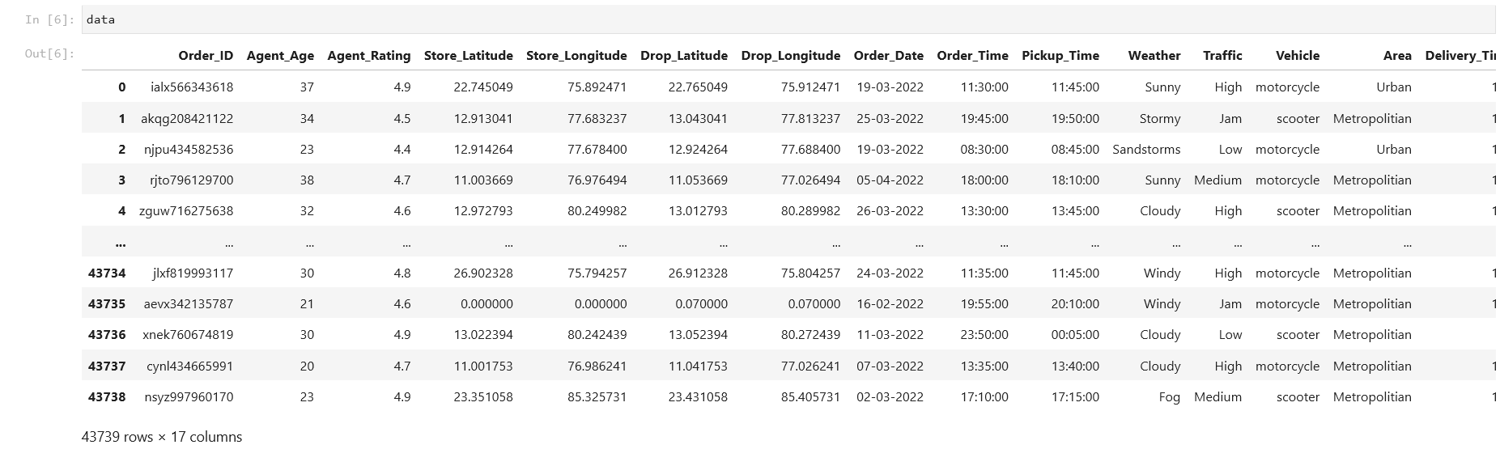

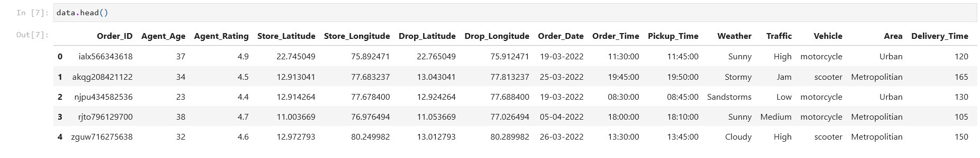

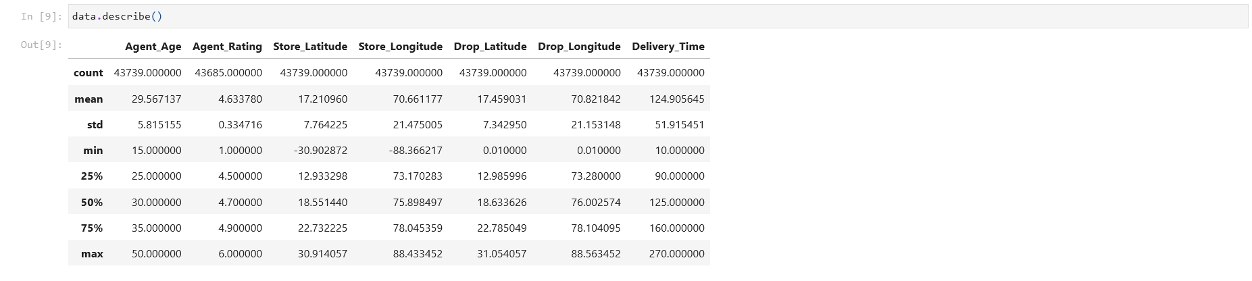

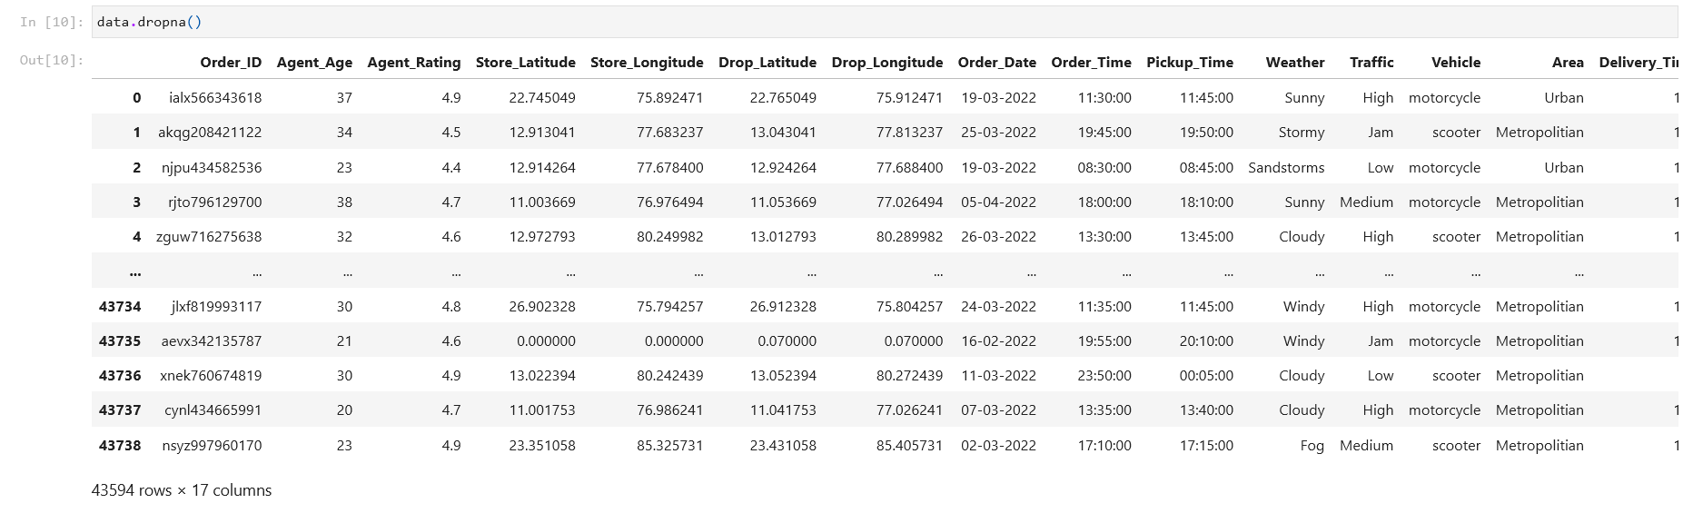

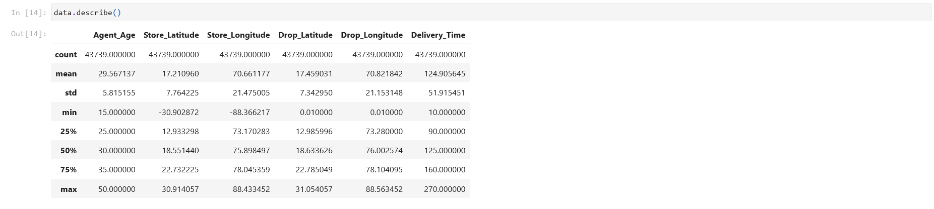

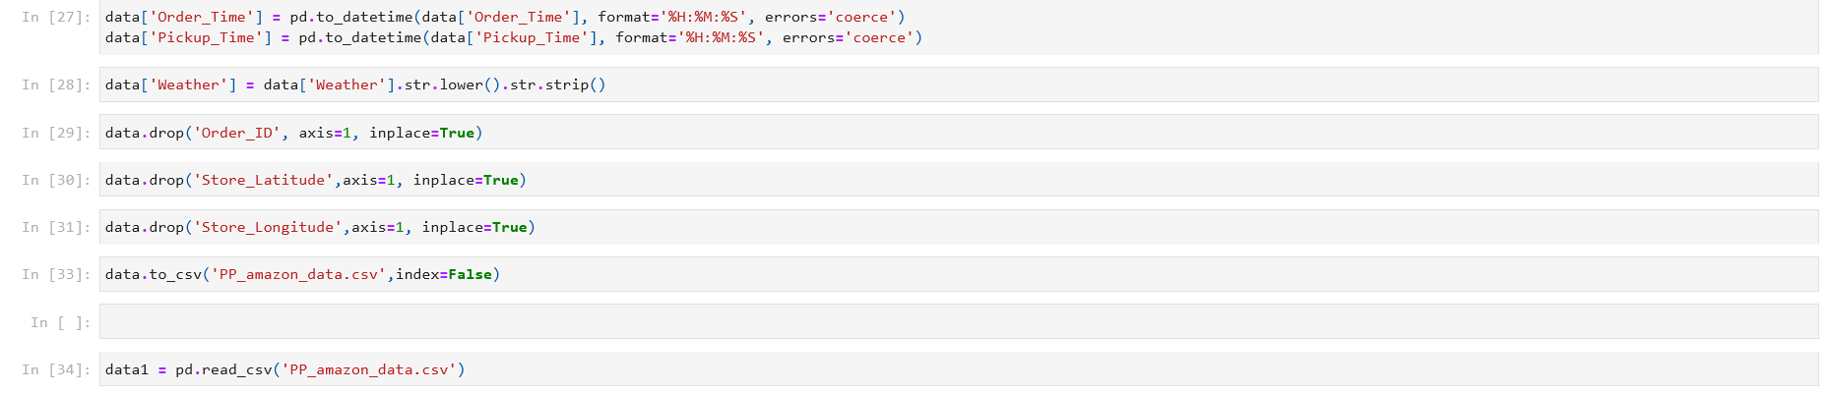

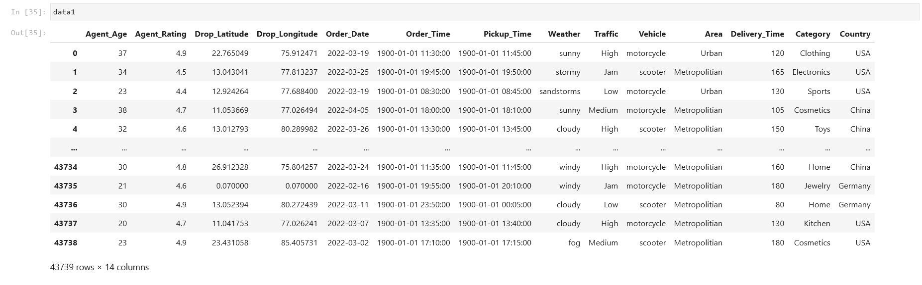

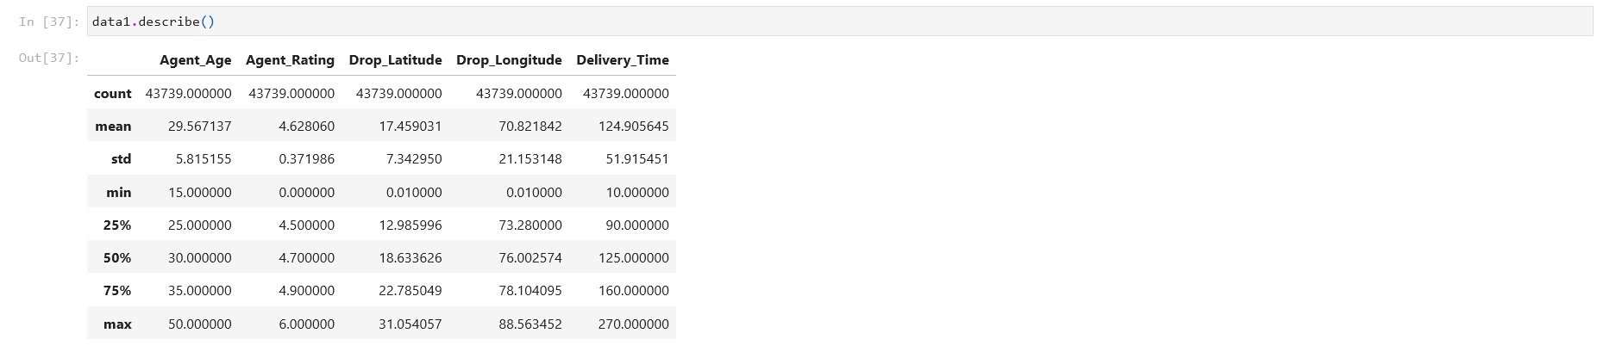

**HIVE Analysis:**

This project analyzes Amazon delivery data using Apache Hadoop and Hive, aiming to uncover insights on delivery performance, agent efficiency, and other metrics based on factors like location, traffic, weather, and product category. The methodology follows a structured approach, combining data setup, storage, and analysis.

**Step 1: Setting up the Hadoop Distributed File System (HDFS)**

The analysis begins by setting up HDFS, a crucial component of Hadoop for distributed data storage. First, a directory named /AmazonProject is created in HDFS to store the dataset. The Amazon delivery data file, PP_amazon_data.csv, is then uploaded from the local environment to this directory. HDFS’s distributed architecture allows the data to be stored across multiple nodes, which ensures redundancy and high availability, enabling efficient processing of large datasets.

**Step 2: Creating a Database and Table in Hive**

With the data stored in HDFS, we proceed to set up Hive, a data warehouse tool in Hadoop that provides SQL-like querying capabilities. A new database called amazon is created in Hive, and all project-related tables are stored within this database for organization and easier access.

Within this database, a table named delivery_data is defined to mirror the structure of the CSV data. This table includes columns like Agent_Age, Agent_Rating, Delivery_Time, Order_Date, Pickup_Time, Weather, Traffic, Vehicle, Category, Country, and other relevant fields, each specified with an appropriate data type. Once the table is defined, the CSV data is loaded into the delivery_data table. This step converts the raw data into a structured format that allows for complex querying and analysis using HiveQL (Hive Query Language).

**Step 3: Data Analysis Using Hive Queries**

With the data structured in Hive, various queries are executed to analyze and derive insights across multiple dimensions. Each query focuses on a specific aspect of the delivery data, allowing for a comprehensive view of the operational performance. Below are the primary queries and the insights they provide:

1. **Average Delivery Time by Product Category**  
   This query calculates the average delivery time for each product category. Analyzing delivery times by category helps identify categories that consistently face delays, allowing Amazon to investigate potential reasons, optimize delivery strategies, or allocate additional resources.
2. **Agent Performance by Area**  
   By grouping delivery data by area, this query computes the average agent rating and age within each area. This data helps Amazon understand which areas have the most experienced or highest-rated agents, allowing for strategic assignment of agents based on area-specific needs.
3. **Impact of Traffic on Delivery Time**  
   The delivery data is categorized by traffic conditions (e.g., High, Medium, Low), and the average delivery time is calculated for each category. This analysis shows how different traffic levels affect delivery efficiency, helping Amazon identify potential delays in high-traffic areas. The insights gained can be used to optimize delivery routes or adjust estimated delivery times based on expected traffic.
4. **Average Delivery Time by Weather Condition**  
   Delivery times are grouped by weather conditions, providing insights into how adverse weather impacts delivery efficiency. This query helps Amazon understand which weather conditions are likely to cause delays, enabling proactive measures, such as modifying delivery schedules or providing special equipment for agents.
5. **Most Common Vehicle Type by Weather Condition**  
   This query identifies the most frequently used vehicle types under various weather conditions, which allows Amazon to evaluate the suitability of certain vehicle types in specific weather scenarios. This information can be used to recommend appropriate vehicle types for safe and timely deliveries, depending on the expected weather conditions.
6. **Top Product Categories by Sales Volume for Each Country**  
   By grouping data by country and product category, this query counts the number of sales for each category in each country. It provides Amazon with insights into regional demand patterns, enabling data-driven decisions on inventory stocking, marketing, and promotions for popular categories in different regions.
7. **Average Time Between Order and Pickup by Category and Area**  
   This query calculates the average time between order placement and pickup for each product category and area. Such insights help Amazon understand operational delays in the order-to-pickup cycle, allowing them to streamline the pickup process for categories and areas facing longer wait times.
8. **Average Delivery Time by Traffic and Weather Conditions**  
   Combining traffic and weather factors, this query calculates average delivery times across various traffic and weather conditions. The result provides a nuanced understanding of how combined external factors influence delivery speed, allowing for optimized route planning and better scheduling.
9. **Top Performing Agents by Country**  
   This query filters agents with a rating above 4.5 and groups them by country, showing the highest-performing agents based on their country of operation. This information highlights top agents and allows Amazon to recognize and replicate successful practices in other regions.

10. **Agent Age Group Performance inDelivery Time**

By segmenting agents into age groups, this query calculates the average delivery time for each age group, providing insights into the performance across different age demographics. This could help Amazon identify age groups that tend to perform faster deliveries, aiding in targeted hiring or training initiatives.

**Step 4: Query Execution and Job Management with YARN**

Each query is executed in Hive and processed using YARN, Hadoop’s resource manager, which distributes the computational workload across available resources. Hive and YARN work together to ensure efficient query execution by managing the MapReduce jobs required for each query. The results of these queries offer comprehensive insights into the delivery data, revealing operational trends and potential areas for improvement.



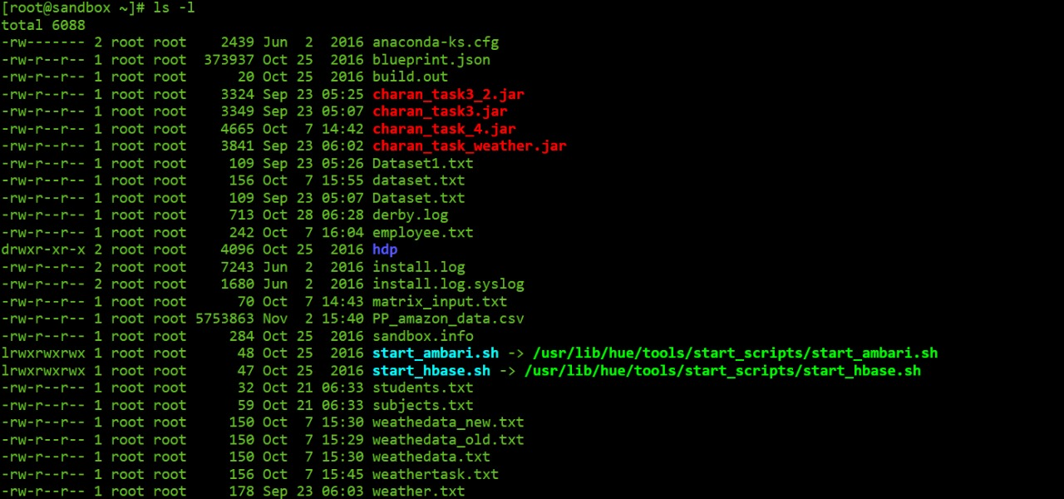

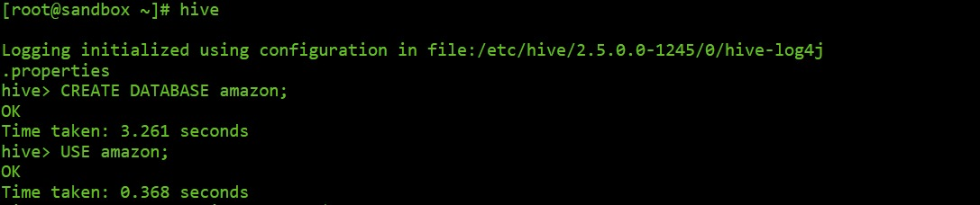

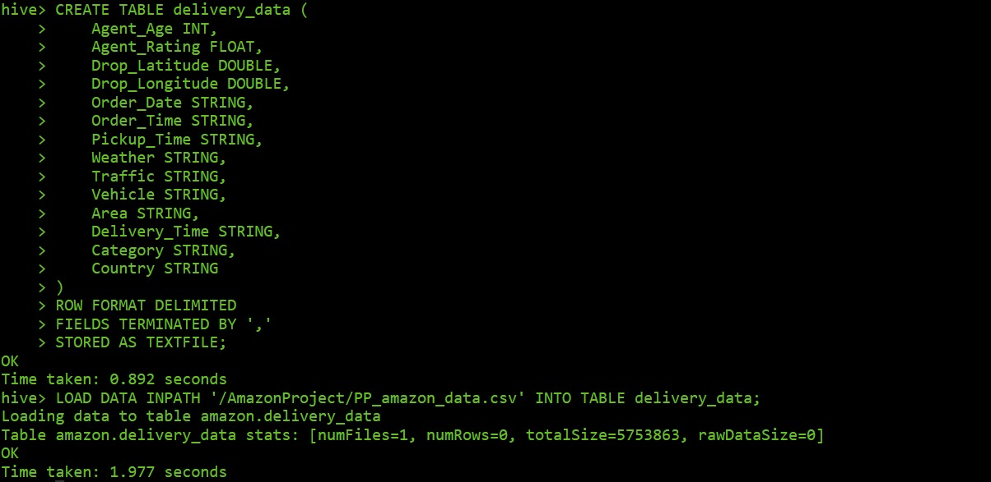

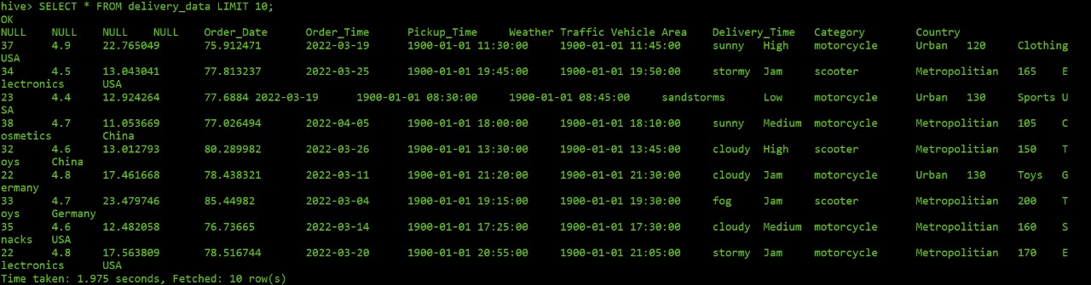

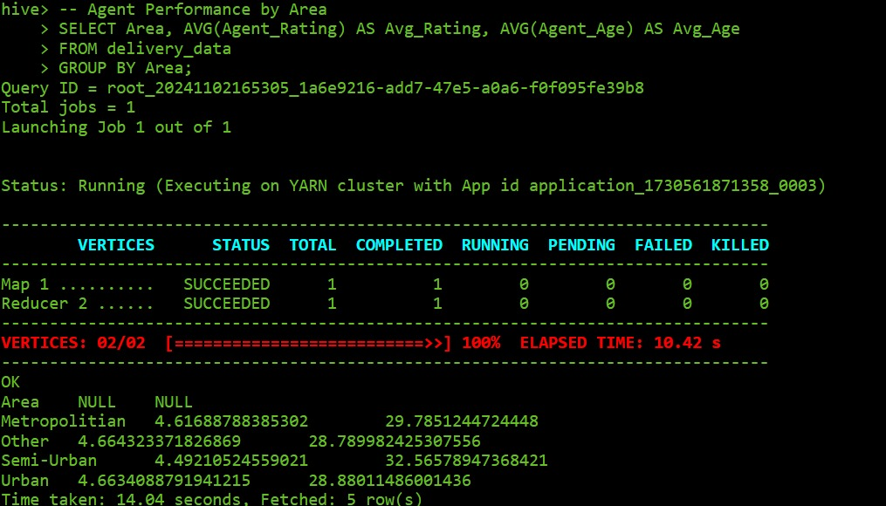

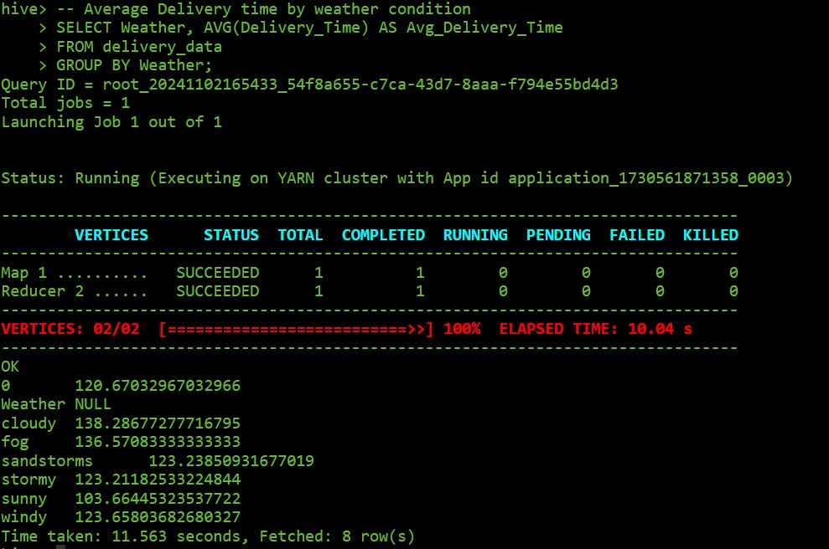

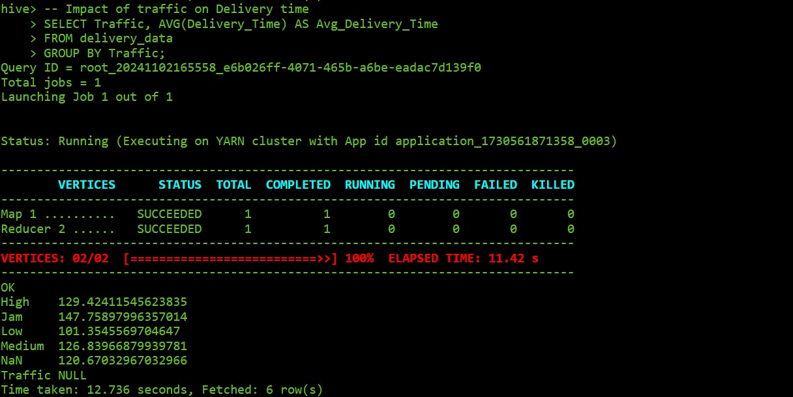

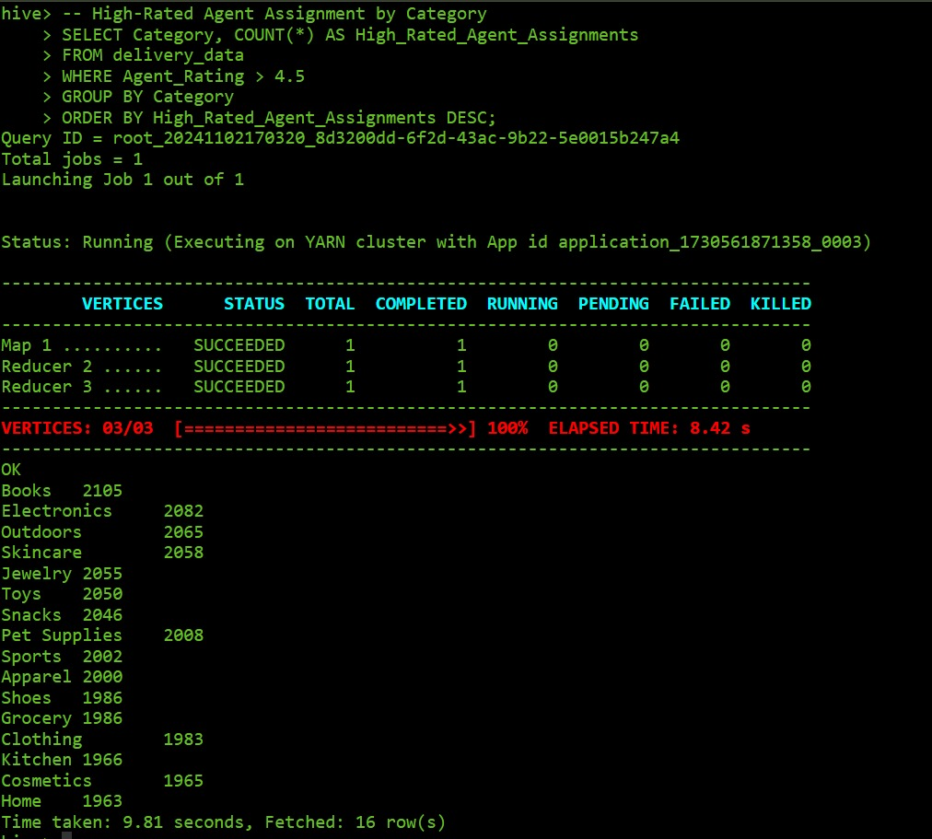

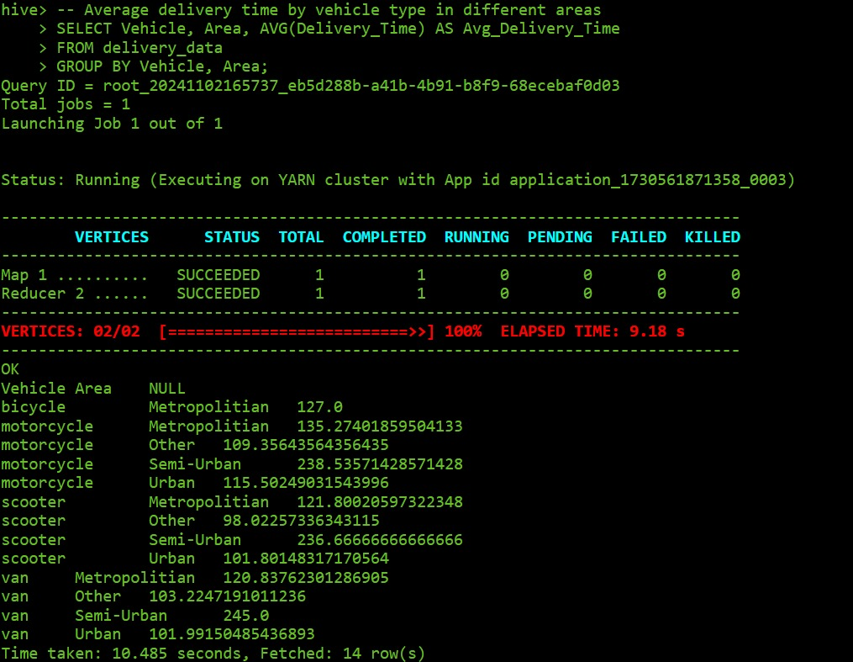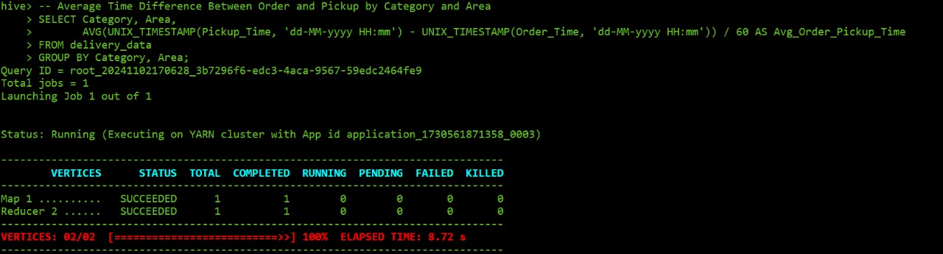

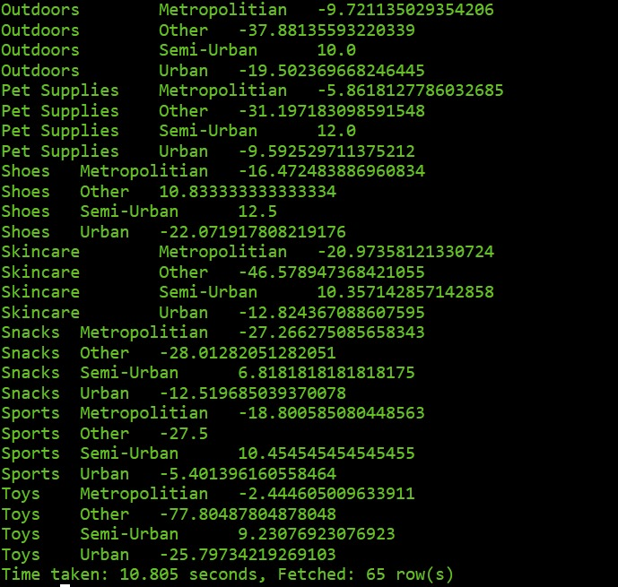

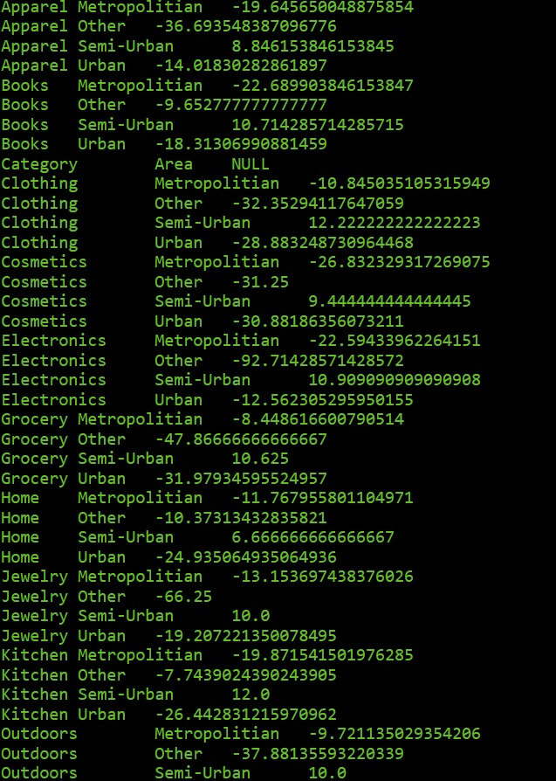

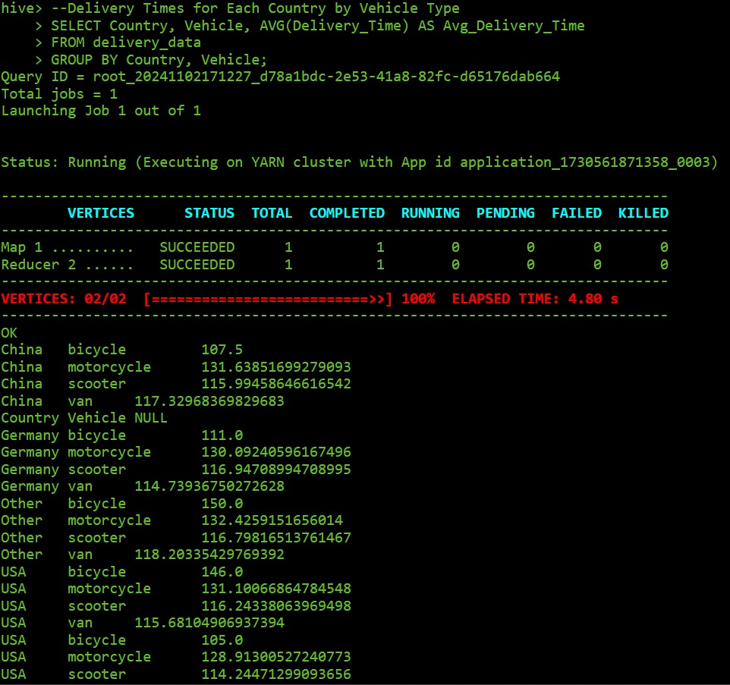

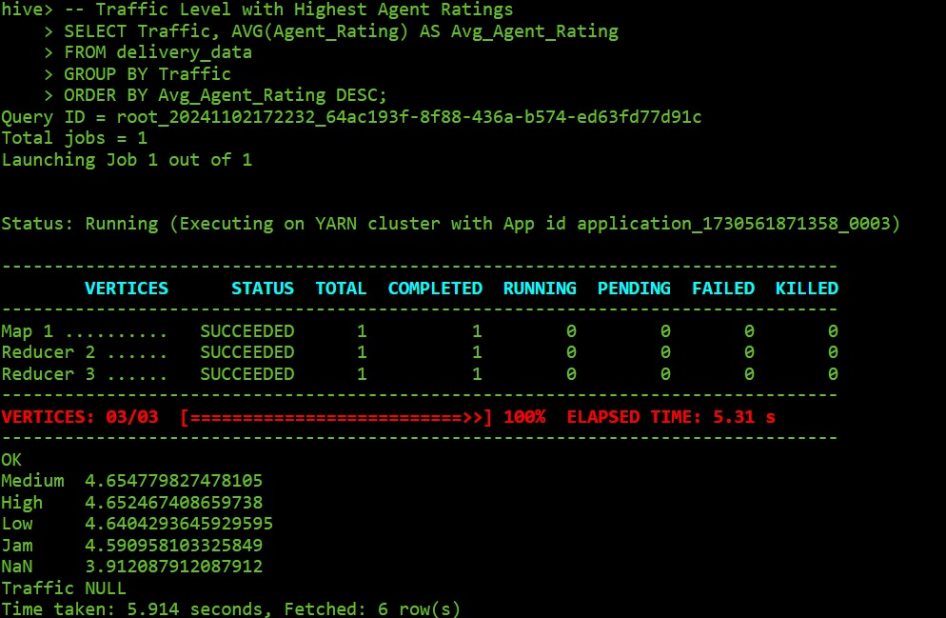

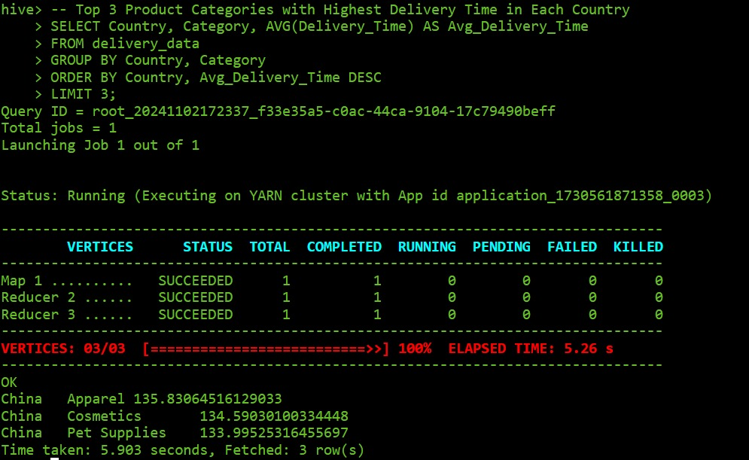

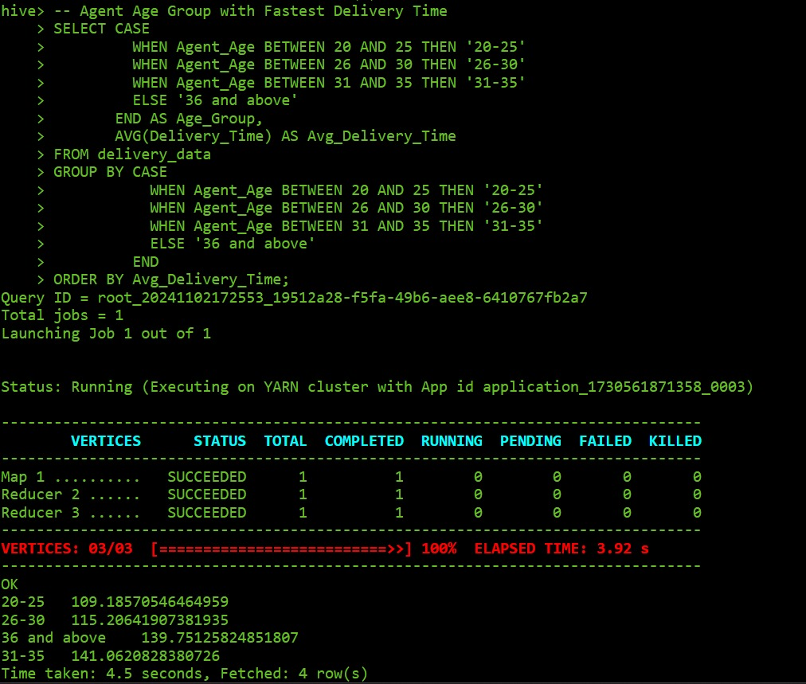

The analysis performed through Hive queries yields several actionable insights:

* Delivery Time Trends: Certain product categories, traffic, and weather conditions lead to higher delivery times.
* Agent Performance: Agent ratings and age vary by area, impacting delivery efficiency.
* Operational Delays: Specific traffic and weather combinations cause delays, which Amazon can mitigate through strategic planning.
* Regional Demand: Popular product categories differ by country, guiding marketing and inventory strategies.

This structured approach to analysing Amazon’s delivery data using Hadoop and Hive provides valuable insights, which can lead to enhanced decision-making for operational improvements, customer satisfaction, and efficient resource management.

**Power BI Analysis**

In Power BI, several calculated columns have been developed using DAX formulas to enhance insights into seller performance, customer satisfaction, and product offerings. The Product Count column extracts the numeric value from the sellerproductcount field, providing a clear measure of the number of products each seller offers. The Positive Rating Count retrieves the total count of positive ratings from the seller ratings field, specifically isolating the number within parentheses to evaluate customer satisfaction effectively. Additionally, the Positive Rating Percentage captures the percentage of positive ratings, providing insight into overall seller performance.

For top-selling products, the Hero Product 1 Rating and Hero Product 2 Rating columns directly reference the ratings of each seller's first and second top-selling products, respectively, offering a quick view of engagement levels. To gain a broader understanding of seller dynamics, the Total Sellers column counts unique seller link entries, indicating the total number of distinct sellers in the dataset. The Average Product Count calculates the mean number of products offered across sellers, serving as a benchmark for product diversity, while the Average Positive Rating Percentage aggregates the positive rating percentages to reflect overall customer satisfaction trends.

Lastly, the Seller Count by Category measures the number of unique sellers within each product category, highlighting the distribution of sellers across various segments. Together, these calculated columns and measures provide valuable metrics for analysing seller engagement, product variety, and overall market presence.

The Power BI dashboard for Amazon Sales consists of five main sections, each designed to provide a comprehensive and interactive overview of sales performance, regional metrics, and areas needing improvement:

**1. Home Page**: Serves as the entry point of the dashboard, summarizing key metrics and providing navigation to deeper analytical insights.

**2. Overview Page:** Offers a snapshot of Amazon's global sales data, including seller distribution, sales volume, and product ratings by location. This page provides a broad perspective on seller demographics and performance, helping users understand geographical patterns and high-level trends.

**3. Analysis Pages (Parts 1 & 2):**

- Analysis Part 1: Focuses on top-selling brands and their performance across different regions, detailing ratings and customer feedback. Key metrics include positive and negative ratings and performance by country and brand.

- Analysis Part 2: Provides a more detailed breakdown of seller ratings, especially in regions like Germany, China, and the US, where performance variability is notable. It dives into seller-specific metrics, positive rating counts, and sales trends by location.

**4. Improvements Page**: Dedicated to identifying underperforming sellers and brands, especially those with lower ratings and higher negative feedback percentages. This section highlights specific sellers by location, with an emphasis on areas where ratings can be improved to enhance customer satisfaction and trust.



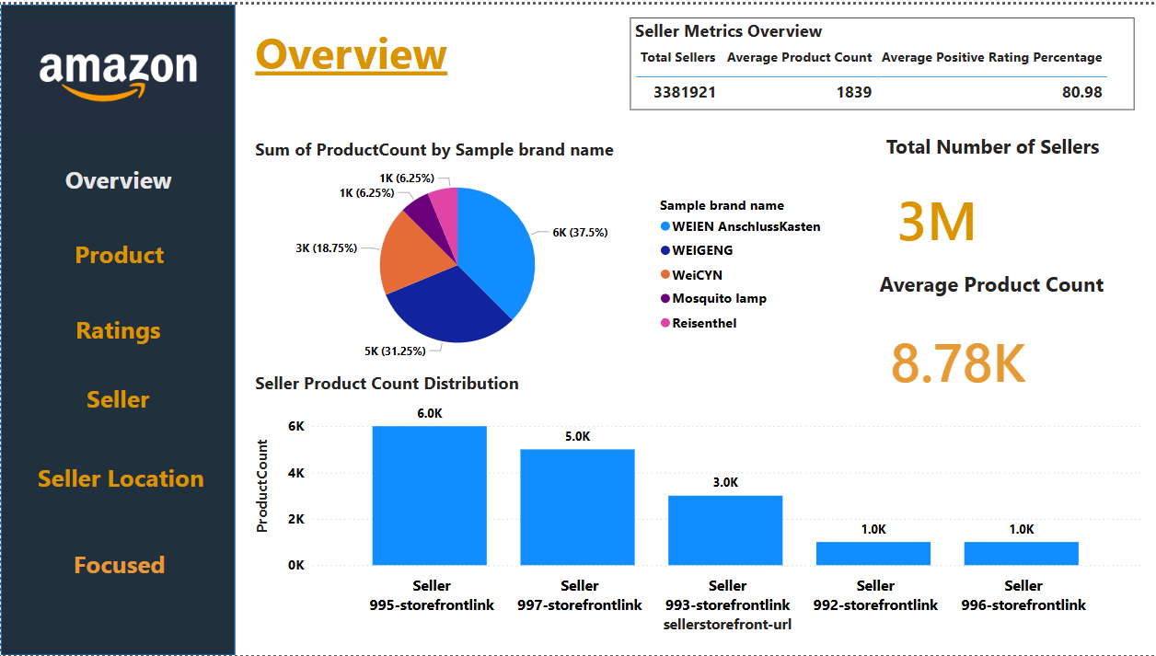

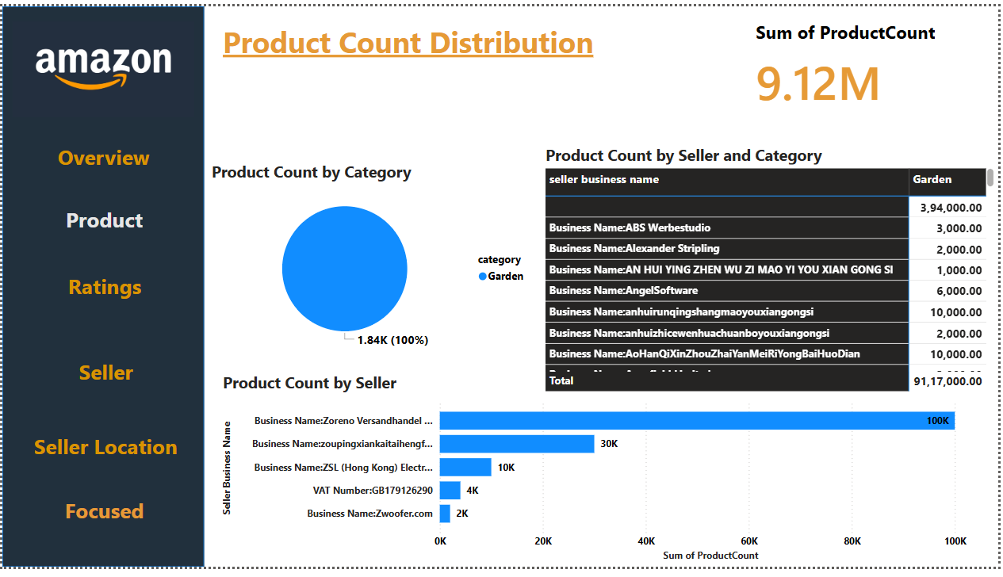

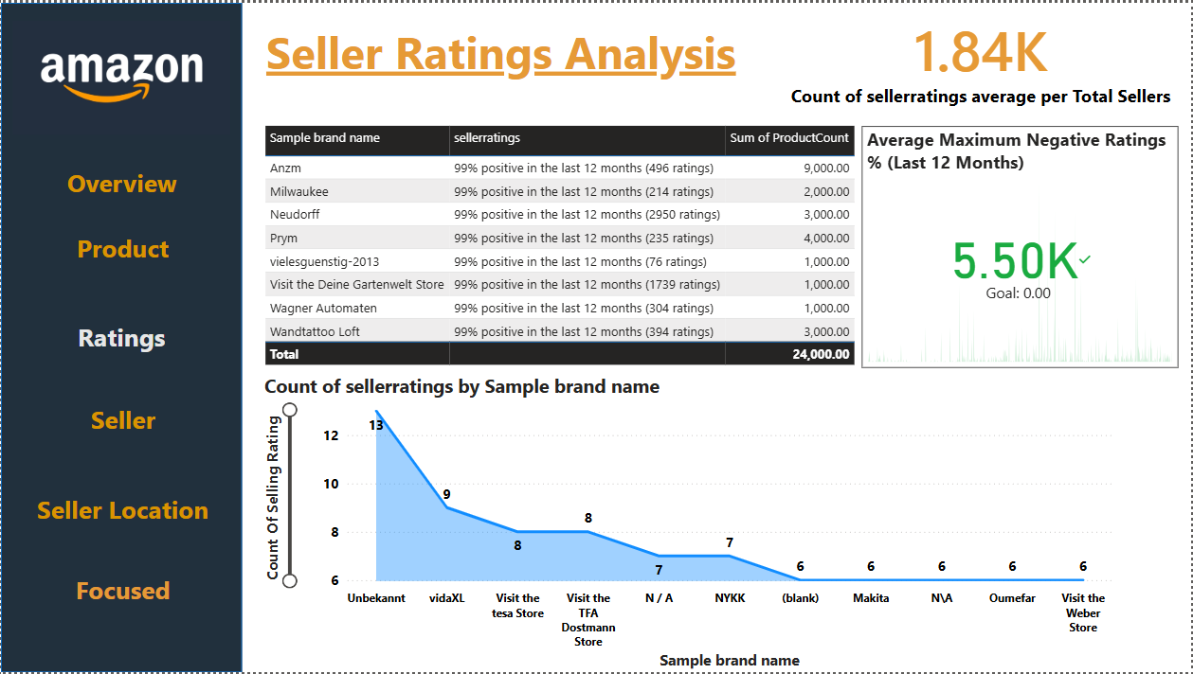

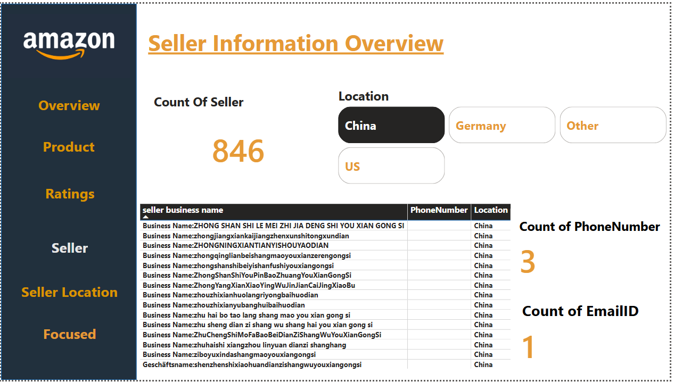

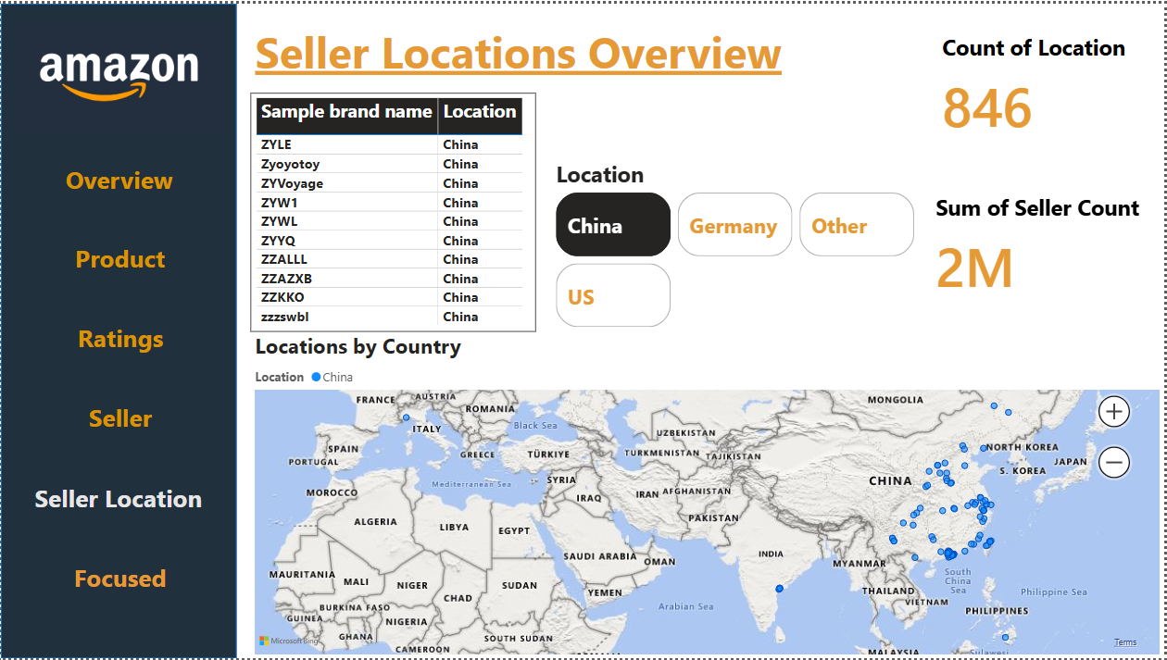

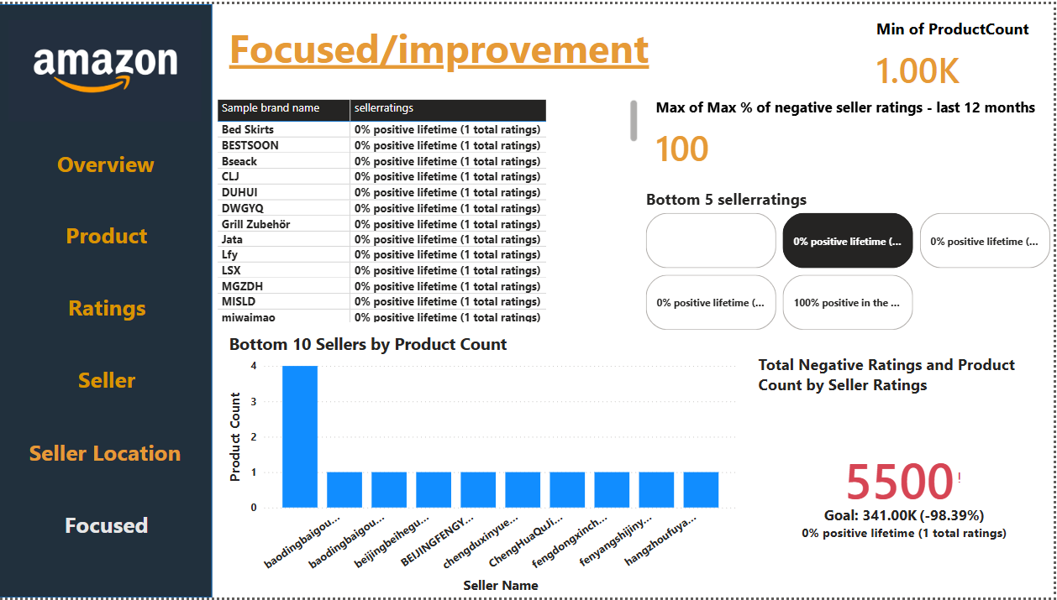

This interactive dashboard structure allows users to drill down into specific regions, brands, and performance metrics, making it a powerful tool for tracking sales effectiveness and identifying areas for targeted improvement.

**R Programming Analysis (R studio)**

The R code provided is designed for a data analysis project focused on understanding various factors that affect delivery times for Amazon orders. This analysis utilizes a dataset containing Amazon order information, including order date, time, pickup time, delivery time, area, and weather conditions. The purpose of this analysis is to uncover patterns and trends that can help in optimizing delivery processes and improving customer satisfaction.

The key steps of the code include data cleaning and formatting:

1. **Data Preparation**: Necessary packages (dplyr, ggplot2, lubridate, and readr) are installed and loaded. The dataset is read in, and relevant columns such as Order_Date, Order_Time, and Pickup_Time are converted to proper date and time formats. Additionally, new columns, such as Month and Time_of_Day (categorized into "Morning," "Afternoon," and "Evening"), are created for further analysis.
2. **Analysis and Visualization**:
   * **Bar Plot of Average Delivery Time by Area**: This plot visualizes the average delivery time across different areas, offering insights into geographic factors affecting delivery efficiency.
   * **Box Plot of Delivery Time by Time of Day**: This plot illustrates the variation in delivery time across different times of the day, identifying peak and off-peak periods.
   * **Line Plot of Average Delivery Time by Month**: A line plot shows how average delivery time changes across months, allowing seasonal patterns to emerge.
   * **Pie Chart of Average Delivery Time by Weather Condition**: A pie chart represents the average delivery time under various weather conditions, providing an understanding of how weather may impact delivery times.

**Bar Plot - Average Delivery Time by Area**

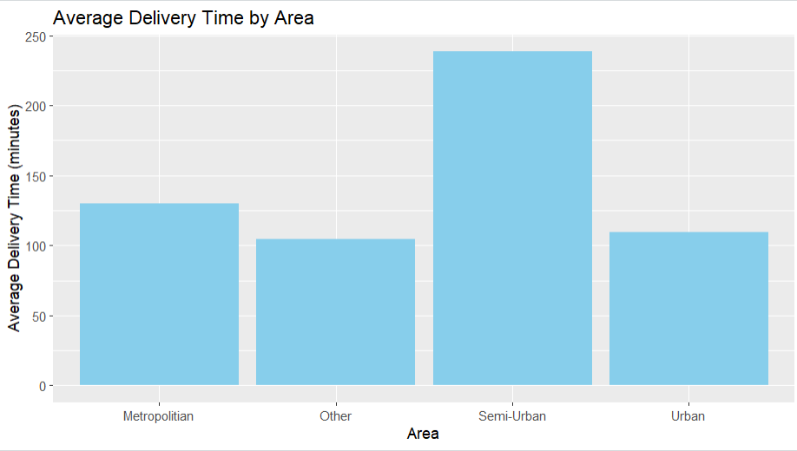

**Box Plot - Delivery Time Distribution by Time of Day**

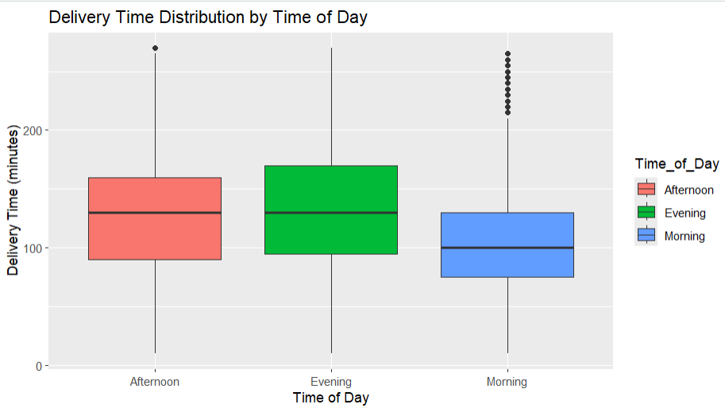

**Line Plot - Average Delivery Time by Month**

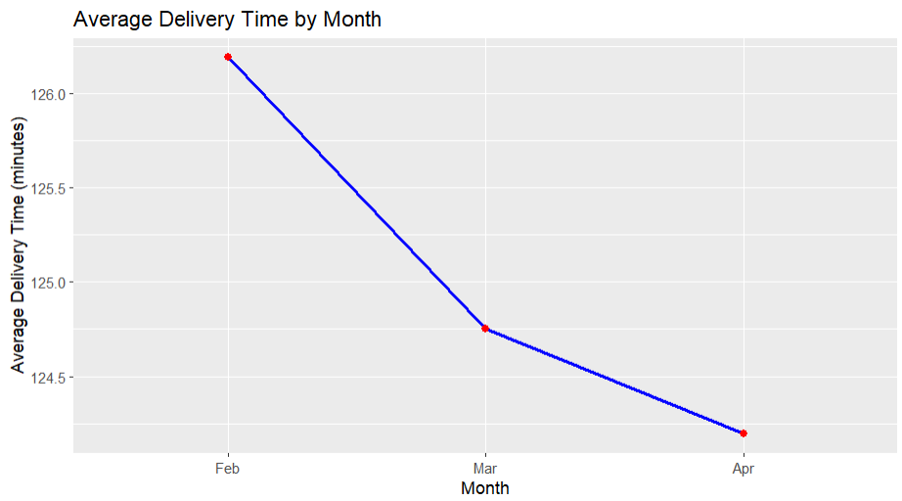

**Pie Chart - Average Delivery Time by Weather Condition with Percentages**36

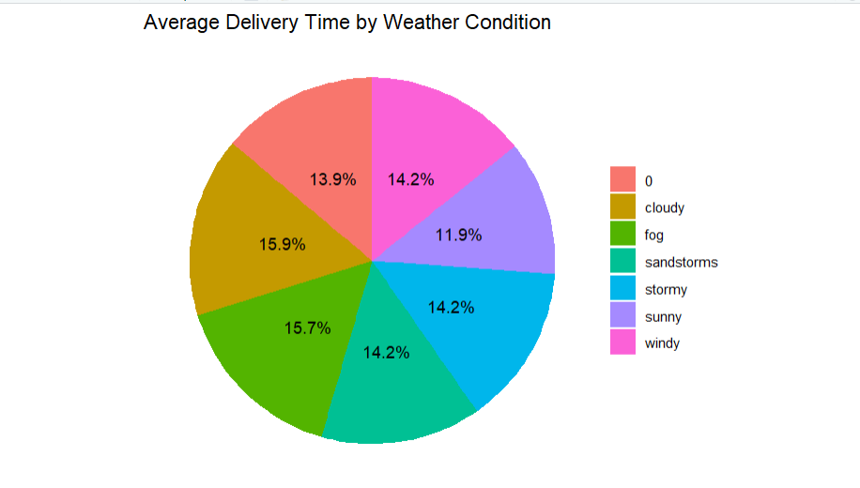

**Concluding Remarks**

Delivery Efficiency Varies by External Factors: Our analysis confirmed that external factors like traffic and weather significantly impact delivery times. High traffic areas and adverse weather conditions lead to increased delivery delays, indicating a need for dynamic routing and contingency planning.

Geographical Variations in Sales and Performance: Sales performance and delivery efficiency were found to vary across different regions. Certain product categories are more popular in specific regions, and delivery agents' ratings also vary by location, suggesting that region-specific strategies could further optimize performance

Influence of Product Category on Delivery Times: We observed that certain product categories consistently faced longer delivery times. This may be due to inventory management or logistical challenges specific to these products, highlighting areas where Amazon could improve efficiency through better resource allocation or targeted interventions.

Customer Satisfaction Tied to Delivery Reliability: Customer satisfaction, as measured by agent ratings and delivery timeliness, appears directly correlated with delivery reliability. Efficient deliveries in favourable conditions were linked to higher satisfaction scores, emphasizing the importance of consistent performance to foster customer loyalty.

Value of Data-Driven Decision Making: The use of Hive, Power BI, and R programming provided a structured approach to extracting and visualizing insights. This data-driven approach enabled us to identify actionable patterns and trends, demonstrating the importance of analytics in optimizing retail sales and operational performance.

Scope for Enhancements with Advanced Techniques: The project uncovered several opportunities for using advanced data science techniques, such as predictive modelling and real-time analytics, which could further refine sales strategies and delivery processes. Such advancements could equip Amazon to respond even more dynamically to market demands.

**Future Work**

**Advanced Predictive Modelling:** Integrate machine learning algorithms to predict sales performance based on seasonal trends, customer behaviour, and external factors like weather and traffic. This could enhance Amazon's capability to make proactive decisions regarding inventory, pricing, and marketing.

**Expansion of Data Sources:** Utilize additional datasets, such as competitor performance data, customer feedback from social media, and economic indicators, to gain a more comprehensive view of the retail landscape and refine sales strategies.

**Real-Time Analytics:** Develop real-time data streaming capabilities to continuously monitor key metrics, such as delivery times and sales trends, enabling instant adjustments to operations and strategies in response to evolving market conditions.

**Optimization of Resource Allocation:** Conduct further studies to optimize delivery routes and agent assignments based on historical performance data, traffic conditions, and customer density, reducing operational costs and improving delivery speed.

**Customer Segmentation and Targeting:** Implement deeper customer segmentation analysis to personalize marketing strategies for different demographic groups, potentially increasing customer satisfaction and sales.

**Integration with AI-powered Recommendation Systems:** Explore the impact of integrating AI-driven recommendation systems to personalize the shopping experience further, increasing conversion rates and customer retention.